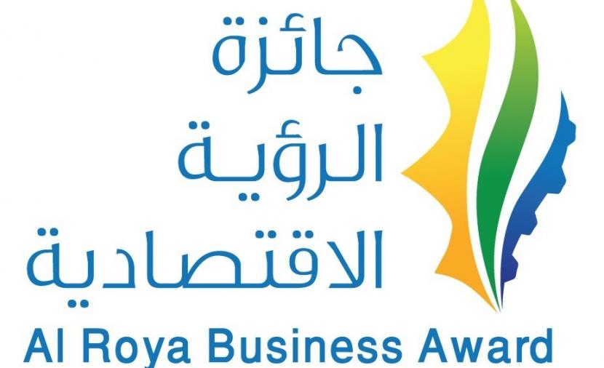

Entrepreneurship Category
(SMEs – Student Companies)

Nomination Form
Special Conditions:
Before proceeding, kindly review the general nomination requirements available on the "Al-Roya" newspaper website:

- The enterprise must be at least two years old at the time of application, while student-run companies need to be at least one year old.
- The company's activities must generate strong financial and economic returns.
- Include the CR with a brief overview of the activities, services, and any branches, if applicable.
- Make all necessary arrangements for the jury team if the evaluation involves field visits to the project

Basic Data:
Enterprise name:

Enterprise owner:

Sector:
Governorate: State:
Phone: E-mail:

Project data submitted for the competition:

Overview of an enterprise:

The final enterprise product:

The economic feasibility of an enterprise’s activities:

Competitive advantage:

The number of employees and Omanization percentage:

The average total income earned during the last three years:
2022:
2023:
2024:
Ensuring facility compliance with HSE regulations:

Enablers of activity sustainability:

Marketing plan:

Development and its determinants:

Social responsibility initiatives, if applicable:

Past national and international recognitions (if applicable):

Additional relevant details:

Note: Please ensure all data is completed accurately and attach the necessary supporting documents for reference during the evaluation process. Failure to do so will result in disqualification.
**********

