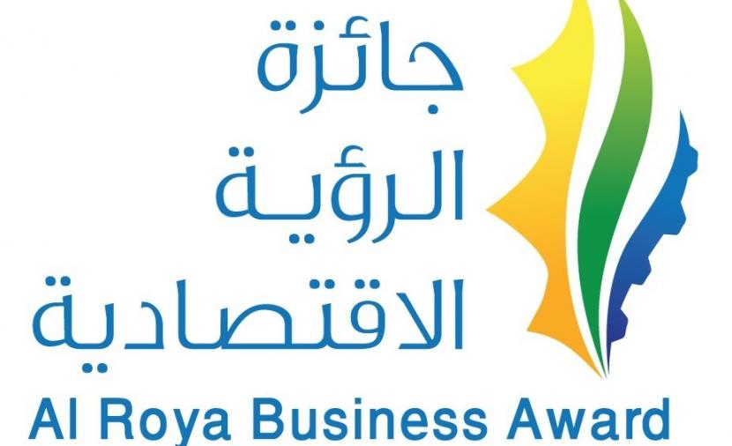

Large Companies Category

Nomination Form
Special Conditions:
Before proceeding, kindly review the general nomination requirements available on the "Al-Roya" newspaper website:

- The company must be at least three years old at the time of application.
- The company's activity should focus on generating tangible economic development revenue.
- Make all necessary arrangements for the jury team if the evaluation involves field visits to the project

General Information:
Company name:
Sector:
Governorate: State:
Phone: E-mail:

Information about the company:

Overview of a company:

Projects and agreements that have been implemented or are currently ongoing:

Economic & development feasibility:

Analysis of key performance indicators (KPIs):

The number of employees and Omanization percentage

The average total income earned during the last three years:
2022:
2023:
2024:

Competitive advantage of a facility:

Ensuring facility compliance with HSE regulations:

Sustainability enablers for activities:

A Marketing plan:

Determinants and development:

Social responsibility initiatives, if applicable

Past national and international recognitions (if applicable):

Additional relevant details:

Note: All data must be filled out accurately, and the documents supporting the answers must be attached for reference during the evaluation process, otherwise the candidate will be disqualified.
**********

